Weekly Report

On

“Healthcare guidance”

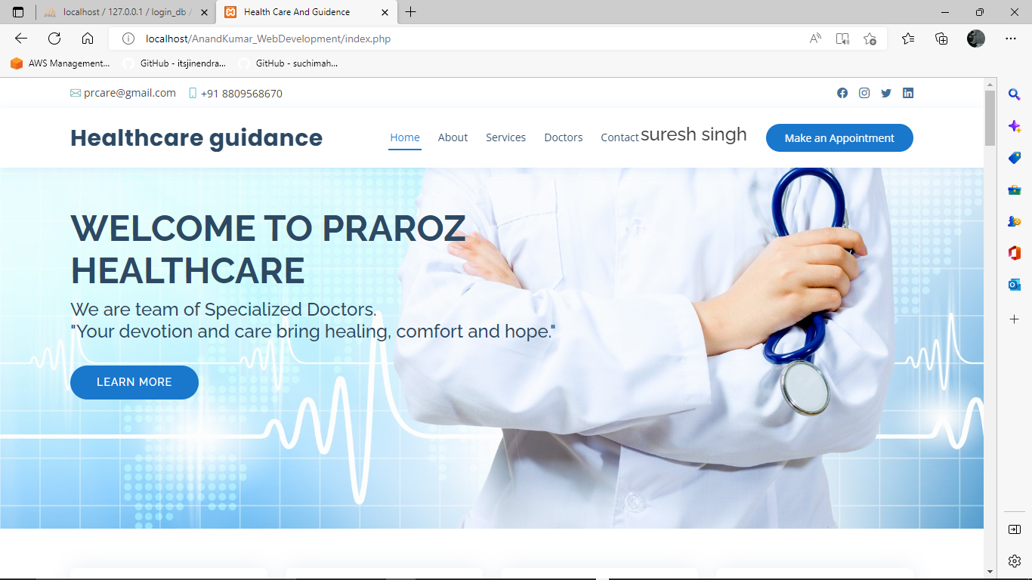

Prepared

By

Anand Kumar

(STU629f05287316d1654588712 )

Department of Computer Science Engineering

Trident Academy Of Technology

Biju Patnaik University of Technology

November 2022

**Week 1**

**Problem Statement: HEALTHCARE GUIDANCE**

**Background of the Problem:**

**We are working on a HealthCare Guidance Website for health care sector. Everyone wants appointment with a good doctor on time but it’s also a difficult task for the patients to get a appointment on required time with a good doctor. To bridge the gap between this we decided to build a healthcare and guidance website.**

**Healthcare Guider Website is basically useful to any person who wants to save time and take doctors appointment online mode and also opt for online consulation through video chat and voice call. Patients can also make online payments to doctor through there UPI ID or net banking . All the data of patients doctors and patients appointment will be stored in different tables of database and can be fetched on the website. To use and acess all the features of website user have to login through his/her email id.**

**User / Customer:**

**. Patients**

**. Doctors**

**. Anyone**

**Week 2**

**Proposed Solution:**

**Healthcare Guider Website is basically useful to any person who wants to save time and take doctors appointment online mode and also opt for online conciliation through video chat and voice call. After getting appointment from the doctor the conformation email will be provided to both patients and the doctor, inside that email all the details of patients will be provided to the doctor with appointment timing and a meeting joining link of Google meet and the details of doctors will be sent to the patients with appointment timing and Google meet link for the meeting. All the appointments of the user will be stored in appointment table and is fetched to website in Appointments menu. User can also cancel and change appointment. Patients can also make online payments to doctor through there UPI ID or net banking . All the data of patients doctors and patients appointment will be stored in different tables of database and can be fetched on the website. To use and access all the features of website user have to login through his/her email id. And new user can Signup through their email id .Full email validation will be used ,no email registered before will be used to signup, they can only login not signup full account security will be given to every user. All the user data like name ,email, phone number , age, gender, date of birth will be stored in user table inside the database made inside PhpMyadmin. The Database is connected to the website using php as a backend language. Doctors will also be provided with login email and password which will be created by the website admin. Using that email doctors can login and see their patients details. All the doctors will be verified and the admin can add and remove doctor. All the user have a authority to edit and delete their profile.**

**I used PHP and Mysql as Backed language to fetch and operate data and for Frontend i Have used HTML ,CSS, Javascript and Bootstrap . I have also used Xampp Apache server And Phpmyadmin to create SQL database and to connect backend and frontend i have used php as a backend language and run it on localhost of browser.**

**Features :**

**The main feature of this app is that it provides a good platform to create a clear communication between doctors and patients.**

**All the patients have free access to chat with the doctors they have taken appointment.**

**Taking appointment through our website is easy and time saving.**

**The website UI is fully user friendly and easy to use.**

**It fetches data very fast reload time is not so disturbing.**

**All the user data are managed and fetched very carefully without any data leakage with fill security. User password data is stored in the form of password hash so that only user can know it.**

**Advantages :**

**User friendly , fast and time saving services are provided to every user.**

**All the doctors are verified doctors with good patients record.**

**We provide you the appointments from good quality doctors from advance hospitals present in India at very pocket friendly price.**

**We provide direct appointment to the without any delay on time.**

**Example of Existing Solution:**

**Apollo24/7** [**https://www.apollo247.com/**](https://www.apollo247.com/)

**Comparison with Existing Solution:**

|  |  |  |
| --- | --- | --- |
| **features** | **HEALTHCARE GUIDANCE** | **APOLLO247** |
| **100+ reputed doctors** |  |  |
| **Anytime doctors availability** |  |  |
| **Fullonline services available** |  |  |
| **Instant appointment** |  |  |

**Week 3**

**User Flow:**

**(Flow Chart)**

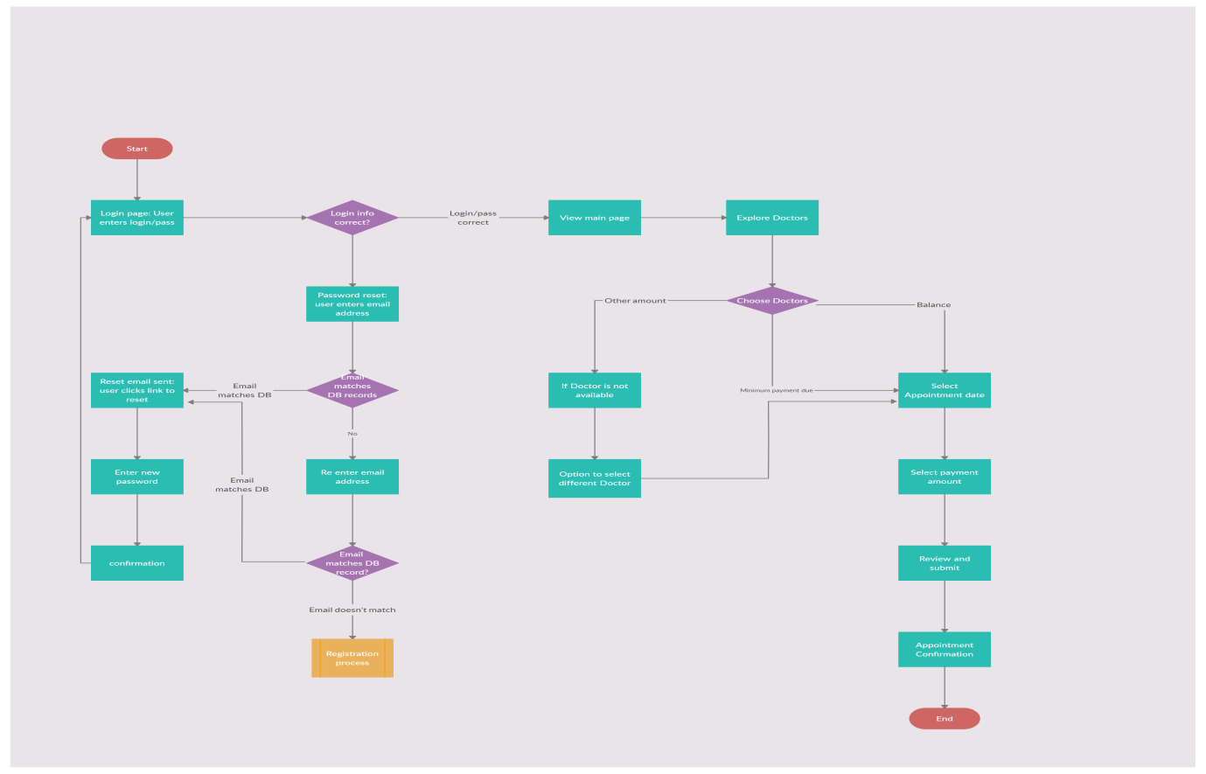

**Timeline Chart (Gantt Chart):**

**Week 4**

**Link for the Website (Hosted on GitHub):**